Fundamentals of Machine Learning

Final project

By

Joshna Katta

library(dplyr)

##   
## Attaching package: 'dplyr'

## The following objects are masked from 'package:stats':  
##   
## filter, lag

## The following objects are masked from 'package:base':  
##   
## intersect, setdiff, setequal, union

library(caret)

## Loading required package: ggplot2

## Loading required package: lattice

library(ISLR)  
library(factoextra)

## Welcome! Want to learn more? See two factoextra-related books at https://goo.gl/ve3WBa

library(ggplot2)

fuel_data<- read.csv("C:/Users/Joshn/Downloads/fuel_receipts_costs_eia923.csv",na.strings="")  
  
colSums(is.na(fuel_data))

## rowid   
## 0   
## plant_id_eia   
## 0   
## plant_id_eia_label   
## 11165   
## report_date   
## 0   
## contract_type_code   
## 238   
## contract_type_code_label   
## 238   
## contract_expiration_date   
## 344302   
## energy_source_code   
## 1   
## energy_source_code_label   
## 1   
## fuel_type_code_pudl   
## 1   
## fuel_group_code   
## 1   
## mine_id_pudl   
## 391947   
## mine_id_pudl_label   
## 391947   
## supplier_name   
## 3   
## fuel_received_units   
## 0   
## fuel_mmbtu_per_unit   
## 0   
## sulfur_content_pct   
## 0   
## ash_content_pct   
## 0   
## mercury_content_ppm   
## 289482   
## fuel_cost_per_mmbtu   
## 200240   
## primary_transportation_mode_code   
## 58192   
## primary_transportation_mode_code_label   
## 58192   
## secondary_transportation_mode_code   
## 575297   
## secondary_transportation_mode_code_label   
## 575297   
## natural_gas_transport_code   
## 267663   
## natural_gas_delivery_contract_type_code   
## 444190   
## moisture_content_pct   
## 516589   
## chlorine_content_ppm   
## 516589   
## data_maturity   
## 0   
## data_maturity_label   
## 0

fuel_data<-fuel_data[,-c(3,7,12,13,19,20,21,22,23,24,25,26,27,28)]  
  
colSums(is.na(fuel_data))

## rowid plant_id_eia report_date   
## 0 0 0   
## contract_type_code contract_type_code_label energy_source_code   
## 238 238 1   
## energy_source_code_label fuel_type_code_pudl fuel_group_code   
## 1 1 1   
## supplier_name fuel_received_units fuel_mmbtu_per_unit   
## 3 0 0   
## sulfur_content_pct ash_content_pct data_maturity   
## 0 0 0   
## data_maturity_label   
## 0

set.seed(2312)  
data2<-fuel_data %>% sample_frac(0.02)  
index<-createDataPartition(data2$rowid,p=0.75,list=FALSE)  
  
data2_Train<-data2[index,]  
data2_Validation<-data2[-index,]  
  
  
data2_Train<-na.omit(data2_Train)  
data2_Validation<-na.omit(data2_Validation)  
colSums(is.na(data2_Train))

## rowid plant_id_eia report_date   
## 0 0 0   
## contract_type_code contract_type_code_label energy_source_code   
## 0 0 0   
## energy_source_code_label fuel_type_code_pudl fuel_group_code   
## 0 0 0   
## supplier_name fuel_received_units fuel_mmbtu_per_unit   
## 0 0 0   
## sulfur_content_pct ash_content_pct data_maturity   
## 0 0 0   
## data_maturity_label   
## 0

colSums(is.na(data2_Validation))

## rowid plant_id_eia report_date   
## 0 0 0   
## contract_type_code contract_type_code_label energy_source_code   
## 0 0 0   
## energy_source_code_label fuel_type_code_pudl fuel_group_code   
## 0 0 0   
## supplier_name fuel_received_units fuel_mmbtu_per_unit   
## 0 0 0   
## sulfur_content_pct ash_content_pct data_maturity   
## 0 0 0   
## data_maturity_label   
## 0

data3_Train<-data2_Train[,c(9,12,13,14)]  
data3_Validation<-data2_Validation[,c(9,12,13,14)]  
  
set.seed(111)  
norm_model<-preProcess(data3_Train, method = c("center", "scale"))  
  
data3_train_norm<-predict(norm_model,data3_Train)  
data3_Validation_norm<-predict(norm_model,data3_Validation)

set.seed(1254)  
  
fviz_nbclust(data3_train_norm[-1],kmeans,method='wss')

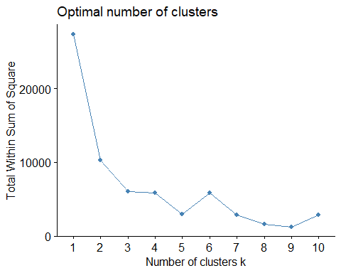

fviz_nbclust(data3_train_norm[-1],kmeans,method='silhouette')

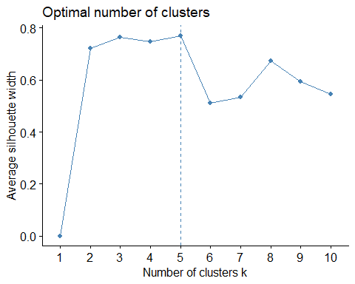

set.seed(5467)  
km<-kmeans(data3_train_norm[-1],centers=5,nstart = 25)  
fviz_cluster(km,data=data3_train_norm[-1])

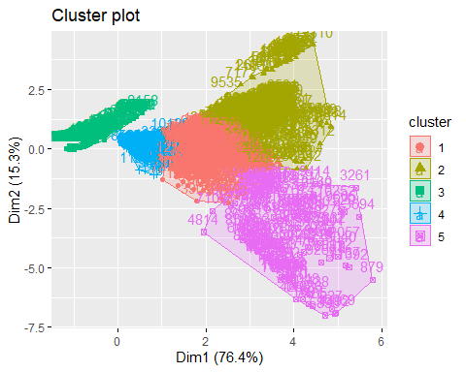

data3_Train$cluster<-as.factor(km$cluster)  
  
ggplot(data3_Train)+geom_point(mapping=aes(x=data3_Train[,1],y=cluster,colour=cluster),position='jitter')+labs(title='K Means')

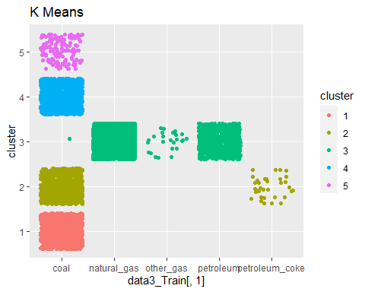

data3_Train%>%group_by(fuel_group_code)%>%summarise(mean_sulphur=mean(sulfur_content_pct),  
 mean_ash=mean(ash_content_pct),  
 avg_fuel_mmbtu_unit=mean(fuel_mmbtu_per_unit))%>%arrange(mean_sulphur)

## # A tibble: 5 × 4  
## fuel_group_code mean_sulphur mean_ash avg_fuel_mmbtu_unit  
## <chr> <dbl> <dbl> <dbl>  
## 1 natural_gas 0 0 1.03   
## 2 other_gas 0 0 0.856  
## 3 petroleum 0.183 0 5.81   
## 4 coal 1.35 10.0 21.3   
## 5 petroleum_coke 5.43 0.435 28.2

data3_Train%>%group_by(cluster)%>%summarise(mean_sulphur=mean(sulfur_content_pct),  
 mean_ash=mean(ash_content_pct),  
 mean_fuel_mmbtu_unit=mean(fuel_mmbtu_per_unit))%>%  
 arrange(mean_ash)

## # A tibble: 5 × 4  
## cluster mean_sulphur mean_ash mean_fuel_mmbtu_unit  
## <fct> <dbl> <dbl> <dbl>  
## 1 3 0.0272 0 1.74  
## 2 4 0.299 5.30 17.6   
## 3 2 3.21 9.66 23.9   
## 4 1 1.11 11.2 24.1   
## 5 5 1.40 39.5 13.7